Santa Barbara Yacht Club Emergency Procedure
Emergency of Life Threatening Injury – Steps
- Render Assistance
- Make contact with coaches or program staff for assistance
- Call for Help & Emergency Medical Attention:
  - Call First: Santa Barbara Harbor Department – VHF Channel 16 or 12 / (805) 564-5531
  - Have the SB Harbor Department call 9-1-1. If you cannot reach the harbor department, call 9-1-1 yourself.
  - *Ask Harbor Patrol where to meet ambulance (there are three available locations – stearns wharf east side, harbor launch ramp or, accommodation dock near Harbor Patrol. (See attached map)
- Monitor and administer first aid if necessary (AED located in the downstairs hallway of SBYC)
- Send someone to meet/direct Emergency vehicles
- Transfer injured to care of Emergency Team
- Debrief and Inform key people: General Manager, Race Director, SBYC Commodore
- Complete an incident report
Be Prepared to tell 9-1-1
- Current location of injured person
- Description of boats
- Where you plan to bring injured person ashore (see map)
- Age / gender / number of injured people
- Type of injury / situation
- Your name and call back number

Once you have contacted Harbor Patrol, give your location and ask where the best place to meet the ambulance will be. 1. Stearns Wharf PLR (east side / outside of wharf) 2. Harbor Launch Ramp 3. Accommodation dock next to the harbor patrol

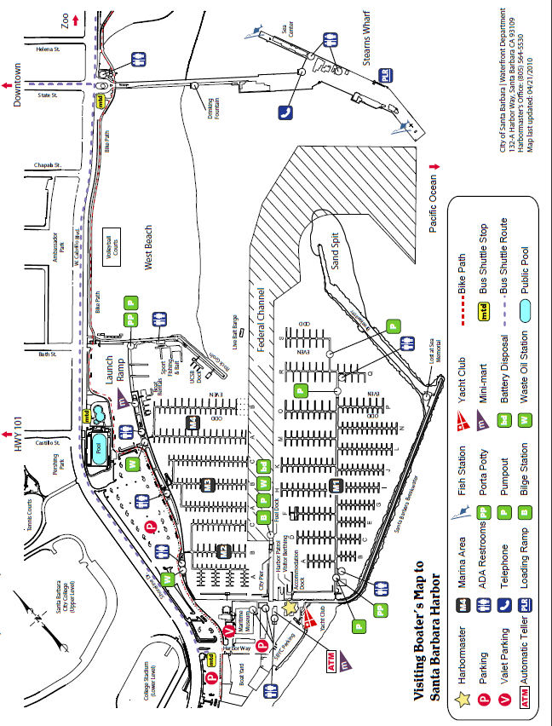

.

Boat / Trailer Storage

Pay parking at Harbor Lot

